Willian Bernatzki Woellner

Student ID 30021175

java 3

Question 1 - Predesign Specification

Table of Contents

Predesign Specification 2

UML Class Diagram 2

Test Table 3

Unit Tests 4

GitHub 4

# Predesign Specification

## UML Class Diagram

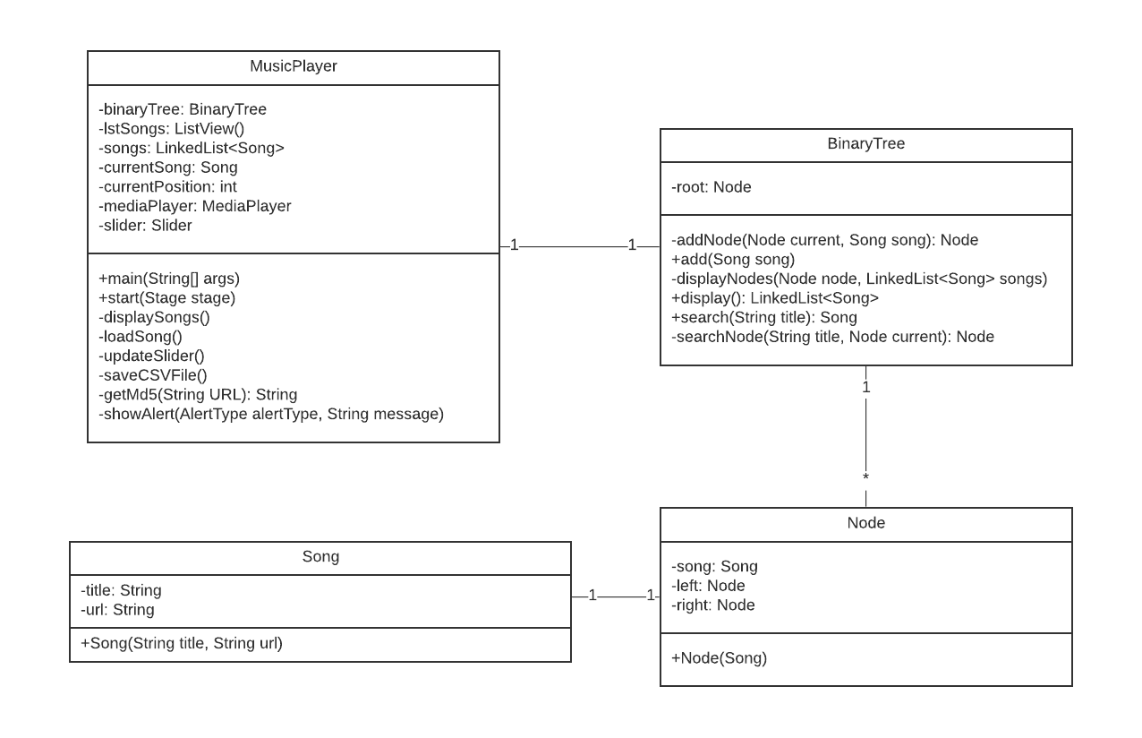

## Test Table

|  |  |  |  |
| --- | --- | --- | --- |
| Test | Expected | Actual | Comment |
| Add Songs to play | When the songs are added to the tracklist, the first song should start playing. |  |  |
| Sort the songs by title | When the songs are added to the tracklist, the first song sorted by title should start playing. |  |  |
| Search a song by title to play | The user should enter the song title and clicks on the Search button for the song to start playing. |  |  |
| Play the next song | When the user clicks on the Next button the next song on the tracklist should start playing. |  |  |
| Play the previous song | When the user clicks on the Previous button the previous song on the tracklist should start playing. |  |  |
| Play the last song | When the user clicks on the Last button the last song on the tracklist should start playing. |  |  |
| Play the first song | When the user clicks on the First button the first song on the tracklist should start playing. |  |  |
| Pause a song | When the user clicks on the Pause button the song that was playing should pause playing. |  |  |
| Stop a song | When the user clicks on the Stop button the song that was playing should stop playing. |  |  |
| Save tracklist on CSV file | The user should click on the Save button to save the tracklist on the CSV file. |  |  |
| Access the help file | The user should click on the Help button to access the Help file. |  |  |

## Unit Tests

|  |  |  |  |
| --- | --- | --- | --- |
| Unit Test | Expected | Result | Comment |
| testAdd function | Add a new Song on the Binary Tree. |  |  |
| testDisplay function(sort and display) | Display a Song from the Binary Tree. This test also tests the sort function, because the display function is used the algorithm to sort the songs to display. |  |  |
| testSearch function | Search a Song on the Binary Tree. |  |  |

## GitHub

The project will be used GitHub to control and distributed the versions of the system. The repository is available on <https://github.com/30021175/MusicPlayerJava>.

